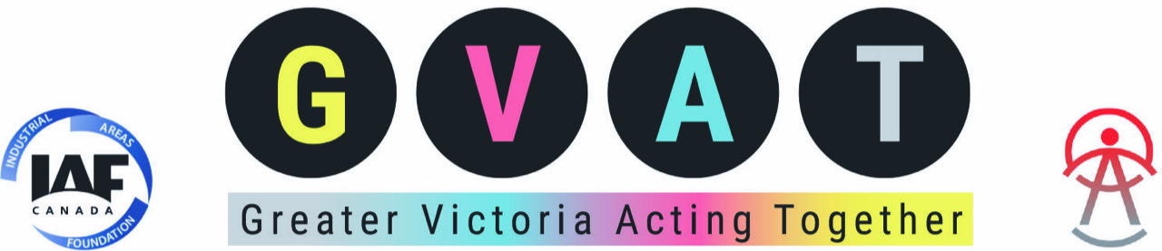

October 5, 2021

Dear CRD Board member:

The book you hold in your hands, *A Good War—Mobilizing Canada for the Climate Emergency*, is the best key yet available for taking on the climate crisis. Klein’s thesis is that to overcome this crisis we will need to mobilize all levels of governments the way we did during the Second World War. Back then, though many Canadians seemed ready to join the war, “… our leaders were reluctant to recognize what [actions] would ultimately be necessary”, writes Klein.

Much of Klein’s book tells how the federal government was re-organized during the Second World War to meet the demands of war. Some re-organizing of municipal and regional governments to address the climate emergency is possible. As well, the CRD and its constituent municipalities and electoral districts can press the provincial and federal governments to create new ministries or special administrative bodies to assist lower levels of government in reducing GHG emissions and furthering climate justice.  The CRD does not have the power of federal or provincial governments but it can make very significant beneficial changes on a smaller scale.

Klein commissioned an Abacus poll in 2019 that showed many Canadians are deeply concerned about the climate crisis and are ready for bold and ambitious actions.  “A core takeaway from this opinion research,” writes Klein (p. 78), “is that our politicians have been underestimating the public. They have failed to take bold action in the face of the climate emergency, insisting the public ‘is not there yet.’ But increasingly, the public is ahead of our elected leaders. A solid majority of Canadians are ready to move beyond incremental policies and to entertain truly transformative climate action.”

We hope this short, readable volume will provide each of you with the examples, evidence and ambition to do much more to reduce GHG emissions in the region. The CRD Board, together with its Committees and Commissions, and in collaboration with member municipalities and electoral districts, has the potential to inspire regional residents, and demonstrate to provincial and federal governments the commitment needed to tackle this climate emergency. We look forward to your leadership!

Yours sincerely,

Jane Welton, co-lead ([janewelton@shaw.ca](mailto:janewelton@shaw.ca))

On behalf of the Climate Action Research Team

Of Greater Victoria Acting Together